**A Brief Survey on Deep Neural Network**

Abstract:

Deep learning a branch of machine learning which is growing popularity in recent years. It’s is gaining interest because of the domain independent functioning ability and elimination of the need of traditional handcrafted feature extraction. In this paper two deep learning network- deep convolutional neural network, deep belief network has been discussed.

1. Introduction:

Deep Neural Network has been applied in many real word data and works specially well in presence of large sample. It has provided quite good results in terms of prediction and regression. Though it gained popularity in recent years, it has been existent before 80’s, but stayed unexplored for decades due to difficulty of implementation. But with improvement of computing hardwires and scalable computing capacity, it has been more convenient to implement deep neural network now than before. Deep neural network has been inspired by human brain. The model tries to mimic the neuron activity in human brain. In brain, at neurons the activation occurs for learning. Similarly, in deep learning sigmoid functions are used as activation function at each neurons of deep neural network.

1. General Architecture:

Deep Neural Network(DNN) is a special type of neural network with numerous hidden layers. Like neural networks, it has neurons for each input variable on each layer. From the Input Layer (Visible Layer), inputs are passed with a weight to all neurons in the next layer. At each next layer, all at all the neurons, neuron activation function (usually sigmoid function) is applied on the input from previous layer.

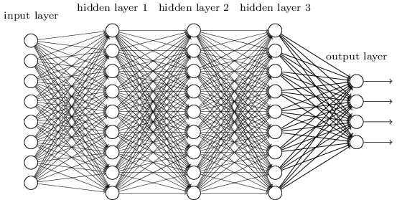

Figure 1:Deep Neural Network (Ref: 4)

When it reaches the output layer, the error is calculated and backpropagated to previous layers. But instead of using just 1 or 2 hidden layers Deep Neural Network uses numerous hidden layers.

1. Applications:

Deep learning has been used in many diverse datasets. But DNN has specially been successfully used in image and speech recognition, semantic and sentiment analysis. And has proven to be more successful than other existent machine learning techniques. In image recognition, it has been documented to outsmart the human. There are different deep learning techniques. Many of them work better on special fields like, for image and object classification - Convolutional Neural Network and Deep Belief Network works very well and for natural language processing Recurrent Tensor Network is most popular.

Popular Market Applications: Amazon’s Alexa and Apple’s Siri.

1. Advantages and Drawbacks:

The major benefit of Deep Learning technique is, it can be made to work without any domain knowledge from data scientists. With increasing need for application of machine learning in diverse fields, it is becoming increasingly difficult for one to have domain knowledge of so many fields. So, using Deep learning reduces the need and helps making the application of machine learning easier on data scientists. DNN also generates features by itself. So, need for hand crafted feature extraction can be reduced by using DNN. Deep learning is especially helpful in Big Data where data is usually unlabeled and unstructured. It is almost impossible to manually generate features from such huge data and having enough domain knowledge of all data is nearly impossible. Deep learning also reduces need for regularization, since DNN works better than existent popular regularizers like l - 2, l - 1. Deep learning is used to extract and regularize features. Then the extracted regularized features can also be used in training with other machine learning models.

The draw backs of the deep neural network are that DNN requires huge amount of data. It is also computationally expensive, for example, model training may take from hours to days or more. So, without using high capacity processing units (like GPUs), it is nearly impossible to implement. Also, finding the right model architecture is very difficult.

1. Different Neural Networks:

There are various types of deep learning network, like Deep Belief network, convolutional network.

* 1. **Convolutional neural network:**

Convolutional neural network is a Multi-layer neural network. Traditional deep learning does not work well for image detection. Images can consist of thousands of pixels. To detect images or object from images it should be analyzed pixel by pixel. So, for 200*200-pixel image there will be lots of weight for each input and neuron and each layer the computation will be too costly even for small image such as this. It can work on audio data also if can be represented as image. So basically, any data that can be represented as image can be analyzed using convolutional neural network.

* + 1. **Convolutional neural network Architecture:**

Convolutional neural network has 4 units: Convolution, Pooling, ReLu, Fully connected layer.

*Convolutional Layer:* Convolutional Deep Neural network treats the image as 4D Data, where along 3 dimensions, the RGB channel resides and on one dimension weights resides. For full input space a set of filters is applied which have limited receptive field. The filter slides along the height and width of the image. At each pass of each filter, a dot product between filter and receptive field is calculated and saved in an activation map for that filter and receptive field. By combining the activation map for input image space for each filter and stacking them along the depth dimension produces output which is the input for the next layer.

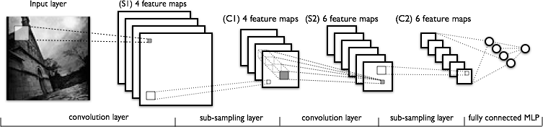

Figure 2:Convolutional neural Network(Ref:2)

*Pooling layer:* The activation map is then divided into equal sized smaller non-overlapping sets. Then, pooling function is applied to down sample from each set. Max poling is the most popular down sampling method which has filter size of 2x2 and from 4 samples 1 highest is chosen, thus reducing the sample size by 75%.

*Rectified Linear Unit layer:* Rectified Linear Unit layer (ReLu) is a normalization Layer. ReLu eliminates mostly the negative values by giving negative values a value of 0. In this layer, the activation function is used to increase non-linearity of the activation map.

*Fully connected layer:* Several Convolutional, Pooling Layers can be stacked to develop deep convolutional network. A Fully connected layer has all the connection to the previous layers and their activation maps. So, they can compute matrix multiplication with bias.

Lastly, based on the derived output value in the output layer, votes are given for each image for each class. Image with maximum votes gets classified as the image that class.

* + 1. **Deep belief network:**

Deep Belief Network(DBN) is a graphical model that learn deep hierarchal representation of training data.

* + - 1. **Architecture:**

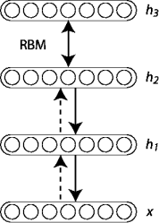In deep belief network, it is said to be a network where Restricted Boltzmann Machines(RBM) are stacked.

It contains subnetwork composed of undirected RBM and directed Bayesian network. Each subnet is a mixture undirected and directed connections. Top two layers of each subnet has RBM interactions and bottom layers are Bayesian. It trains the first layer as RBM that can model raw input data. Then mean activation or samples from the first layer is used as input for second layer. For DBN, good initialization is important. So, each layer uses the hidden layer of previous layer as visible input layer. This continues for all the hidden layers consequently. Each layer learns all input which is more efficient than shallow network. When trained unsupervised DBN can function as feature detectors, while in supervised learning, DBN performs classification.

Figure 3:Deep Belief Network (ref: internet)

* 1. **References:**

1. https://deeplearning4j.org/convolutionalnets.html
2. <https://en.wikipedia.org/wiki/Convolutional_neural_network>
3. <http://deeplearning.net/tutorial/DBN.html>
4. http://neuralnetworksanddeeplearning.com/chap6.html